**Department of Electronic and Telecommunication Engineering**

**University of Moratuwa**

**EN1093 – Laboratory Practice I**



WEIGHT SCALE PROJECT REPORT

Name Index No.

1. H.D.J.Caldera 180079X

2. C.H.W.M.R.A.T.Chandrasekara 180087U

3. C.M.S.D.Chandrasekara 180089D

4. K.L.G.J.Chandula 180092F

Supervisor: Ms. Theshani Nuradha

6th March 2020

**ABSTRACT**

The objective of the project is to build a weight scale which can deliver an accuracy of 10g using a load cell, amplifier and a microcontroller.

The microcontroller used was the Atmega 328p. NI multisim was used to simulate the circuits while the PCBs were designed using Altium Designer.

The basic idea is to obtain a voltage which varies with load from the load cell, amplify it and then use to microcontroller for ADC and calibration. Finally the output weight is displayed on a 16 LCD.

**Table of Contents**

1. INTRODUCTION………………………………………………………………………. 3

1. METHODOLOGY…………………………………………………………………….... 4
   1. Main steps of the project…………………………………………………………… 4
      1. Logical approach……………………………………………………………. 4
      2. Testing on bread board and simulation……………………………………... 4
      3. Manufacturing PCBs………………………………………………………... 5
      4. Coding………………………………………………………………………. 5
      5. Testing full product…………………………………………………………. 5
      6. Making enclosure………………………………………………………….... 5
   2. Algorithm…………………………………………………………………………... 6
   3. Calibration………………………………………………………………………….. 7
   4. Power Supply Circuit…………………………………………………………......... 8
      1. Components used…………………………………………………………… 9
      2. Schematic…………………………………………………………………… 9
      3. PCB layout…………………………………………………………………. 10
      4. Actual View…………………………………………………………………10
   5. Amplifier Circuit…………………………………………………………………...11
      1. Components used……………………………………………………………11
      2. Schematic…………………………………………………………………....11
      3. PCB layout…………………………………………………………………..12
      4. Actual View……………………………………………………………….... 12
   6. Microcontroller Circuit............................................................................................. 13
      1. Pin-out .............................................................................................................13
      2. Components used............................................................................................ 13
      3. Schematic........................................................................................................ 14
      4. PCB layout...................................................................................................... 14
      5. Code.................................................................................................................15
2. RESULTS AND DISCUSSION........................................................................................18
   1. Results........................................................................................................................18
   2. Final Outcome............................................................................................................20
   3. Discussion................................................................................................................. 21
3. REFERENCE................................................................................................................... 22
4. **INTRODUCTION**

Measuring a perfect weight is a vital requirement in the present industry. So with the development of the technology, at present mechanical weighing scales are replaced by electronic weighing scales; which are more accurate and reliable.

A weighing scale using load cells has many advantages compared with other weighing scales. Some of them are,

1. Smaller in size
2. High speed
3. Good accuracy
4. High dependability
5. Reliability
6. Programmable

In our project we used one load cell as it was economical and sufficient for the given necessity. Also we selected to use a 10kg load cell. So this electronic weighing scale is mainly a combination of a load cell, microcontroller and a LCD display.

Input signal from the load cell is amplified and it is fed into the microcontroller. Finally according to the calibration, output result is shown in the LCD display.

Also due to its advantages, easiness to use and increase of efficiency, this project is important in the present technical scenario.

1. **METHODOLOGY**
   1. **Main Steps of the Project**
      1. **Logical approach**

In this project 10kg load cell is used instead of 5kg load cell as a platform of 500g is used to put weights. Then it will exceed the maximum weight limit when 5kg is being measured. Therefore, we used 10kg load cell. -10v and 10v is given to load cell to increase the range of the outputs. For 5kg the output of the load cell was 10mv. Therefore, an operational amplifier circuit of gain of 481 is used amplify the signal. Then the output of the amplifier is measured against different known loads. Then the output voltage is plotted against the weight to get the equation. Then the microcontroller is programmed to output the weight by measuring the input voltage.

* + 1. **Testing on breadboard and Simulation**

**Testing:**

As the first step, we used Multisim to draw schematic diagrams to model the functionality of the circuit. We measure the output voltages of the power supply since we need

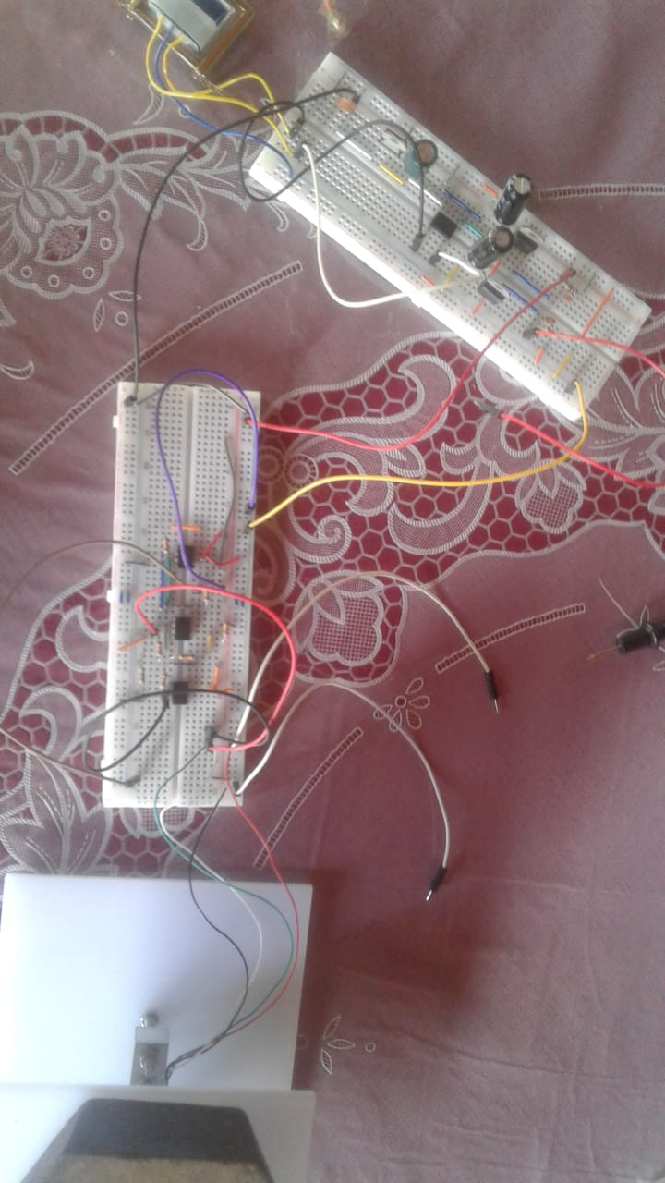**Simulation:** As the next step, we test the circuits on the breadboards. Also we get the output voltages with respect to known weights.

* + 1. **Manufacturing PCBs**

Frist of all we drew schematics using ALTIUM we got layouts of power supply circuit, amplifier circuit and microcontroller circuit. After that we manufactured PCBs using screen printing method. After that we drilled holes and soldered components to the PCBs.

* + 1. **Coding**

While we were manufacturing PCBs, we developed a code using C programming language. Analog to digital conversion and calibration was done in this code. Since we got Analog output from load cell we had to convert it into Digital signal. Calibration was also done using the microcontroller code.

* + 1. **Testing full product**

Having done all these above steps, we tested the overall functionality of the weight scale. Results can be seen in the performance section.

* + 1. **Making enclosure**

Using SOLID WORKS software, we created a suitable enclosure for weight scale. We manufactured it using wood.

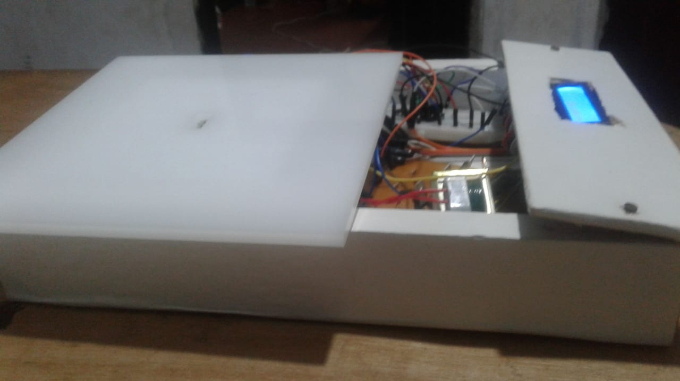

* 1. **Algorithm**

AMPLIFY

LOAD CELL INPUT

ADC BY MICROCONTROLLER

CALIBRATION

* 1. **Calibration**
* **What is a load cell?**

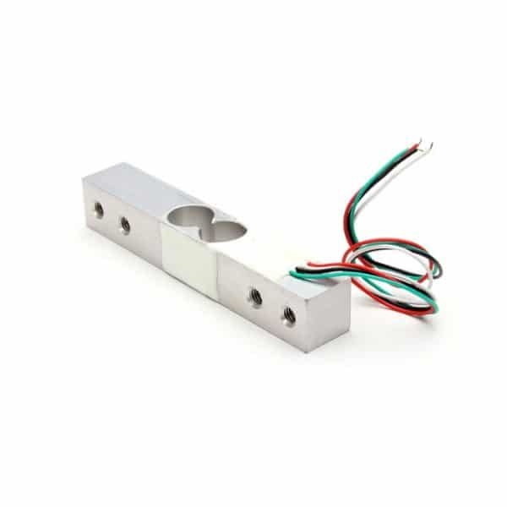This is a type of transducer. A transducer is a device which converts energy from another parameter like an electric signal. It converts a force such as tension, compression, pressure, or torque into an electrical signal that can be measured and standardized. As the force applied to the load cell increases, the electrical signal changes proportionally.

Type of load cells,

* Cantilever load cell
* Pancake load cell
* Canister load cell
* S-type load cell

In this project we used cantilevered load cell. Cantilevered load cell is a strain gauge based low profile bending beam load cell. It is for precision single point load applications.

* **Functionality of a load cell**

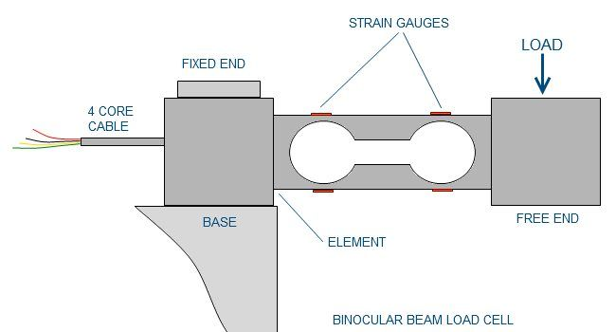

* **Cantilever load cell**

The **Cantilever load cell is** a strain gauge based low profile bending beam load cell and is for precision single point load applications. It is designed for eccentric load sensitivity. A precision machined flexure with superior quality strain gauges **is** used as the load sensing element.

**How was the weight scale calibrated…?**

First we took known weights. Known weights were put on the weight scale and we took output voltages. Output voltages were millivolt range. So we used amplifier circuit to amplify the output millivolt age into voltage range. When we put known weight, we could observe, the output voltages slightly linear. So we assume, when we put unknown weight on it, it gives relevant linear output voltage.

|  |  |
| --- | --- |
| **Weights (g)** | **Output Voltage (V)** |
| 0 | 0.005 |
| 50 | 0.0481 |
| 100 | 0.0962 |
| 250 | 0.2405 |
| 500 | 0.481 |
| 750 | 0.722 |
| 1000 | 0.96 |
| 1500 | 1.43 |
| 2000 | 1.924 |
| 2500 | 2.405 |
| 3000 | 2.886 |
| 3500 | 3.37 |
| 4000 | 3.85 |
| 4500 | 4.33 |
| 5000 | 4.81 |

* 1. **Power Supply Circuit**
     1. **Components Used**

This is used to get +5V, +10V and -10V which are needed for the function of other categories. So the components used are,

* Rectifier IC
* Voltage regulators (LM7805, LM7810, LM7912)
* 3- 470uF, 3- 0.01uF capacitors
* 2- 1k ohm, 560ohm resistors
* Headers
  + 1. **Schematic of the power supply circuit**

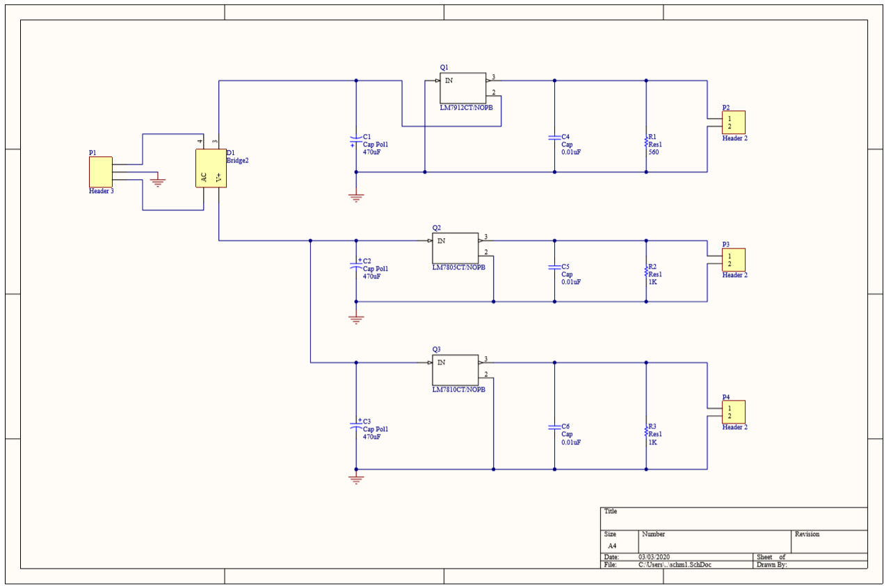

* + 1. **Layout of the power supply circuit**

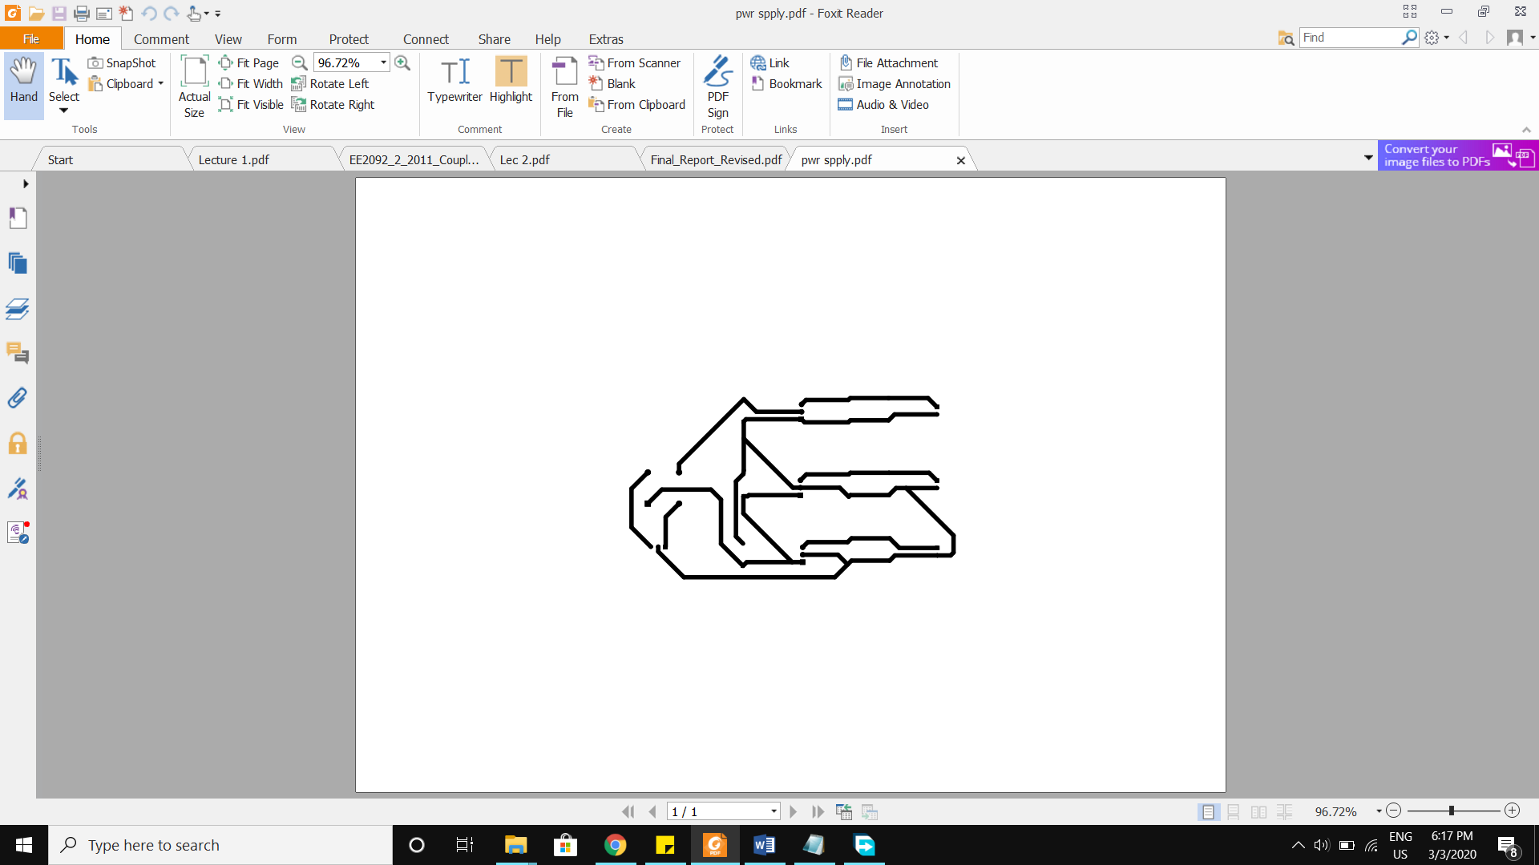

* + 1. **PCB of the power supply circuit (Actual view)**

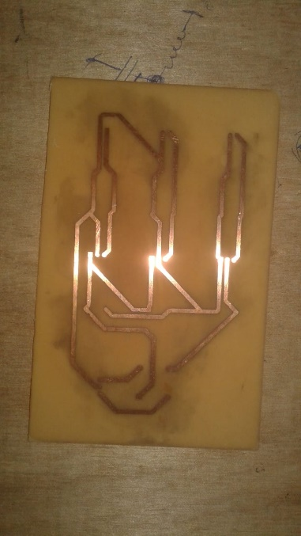

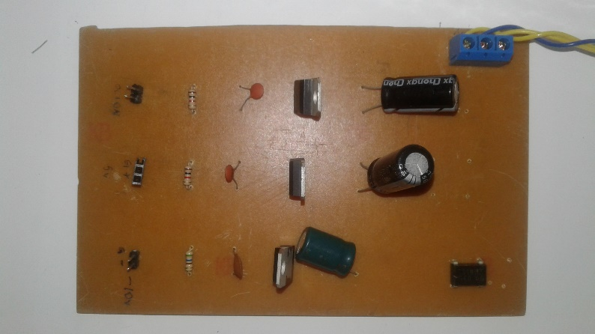

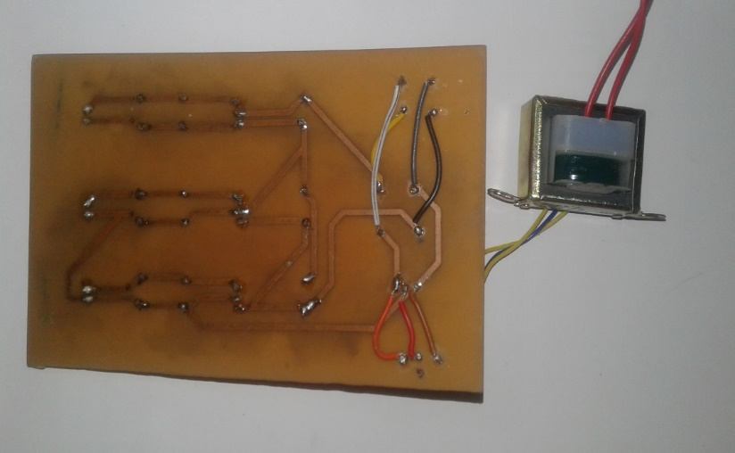

* 1. **Amplifier Circuit**

This is used to amplify the output voltage (mV) of the load cell. The gain of the amplifier is 481. The load cell gives an output of 0v for 0 kg and 10mV for 5kg. Therefore a gain close to 500 is needed. The equation of gain for an our amplifier is given by

G = 1 + 2R/Rg

Selecting R as 24k the required resistance for a gain of 500 is about 96(Ohm). Practically the closest available resistance is 100(Ohm).

* + 1. **Components Used**
* 3- Op Amps (OP07CP)
* 6- 24k ohm, 100 ohm resistor
* Headers
  + 1. **Schematic of the amplifier circuit**

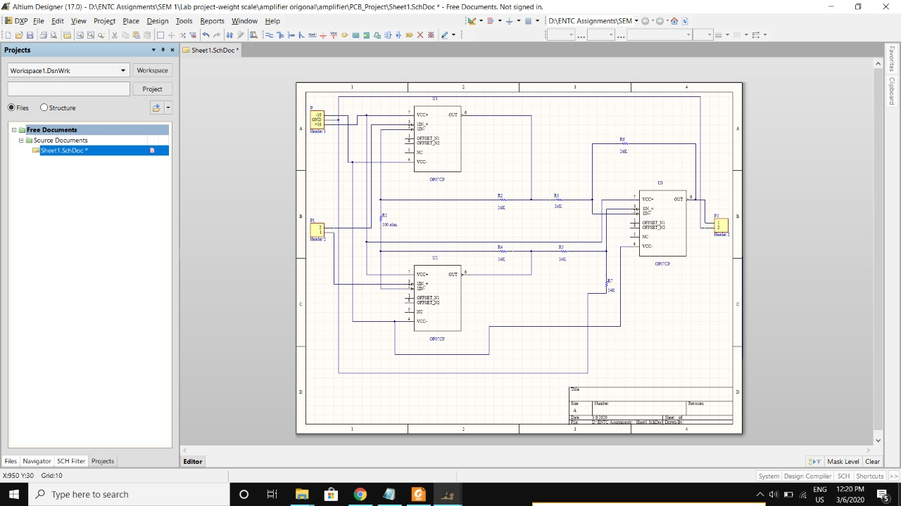

* + 1. **Layout of the amplifier circuit**

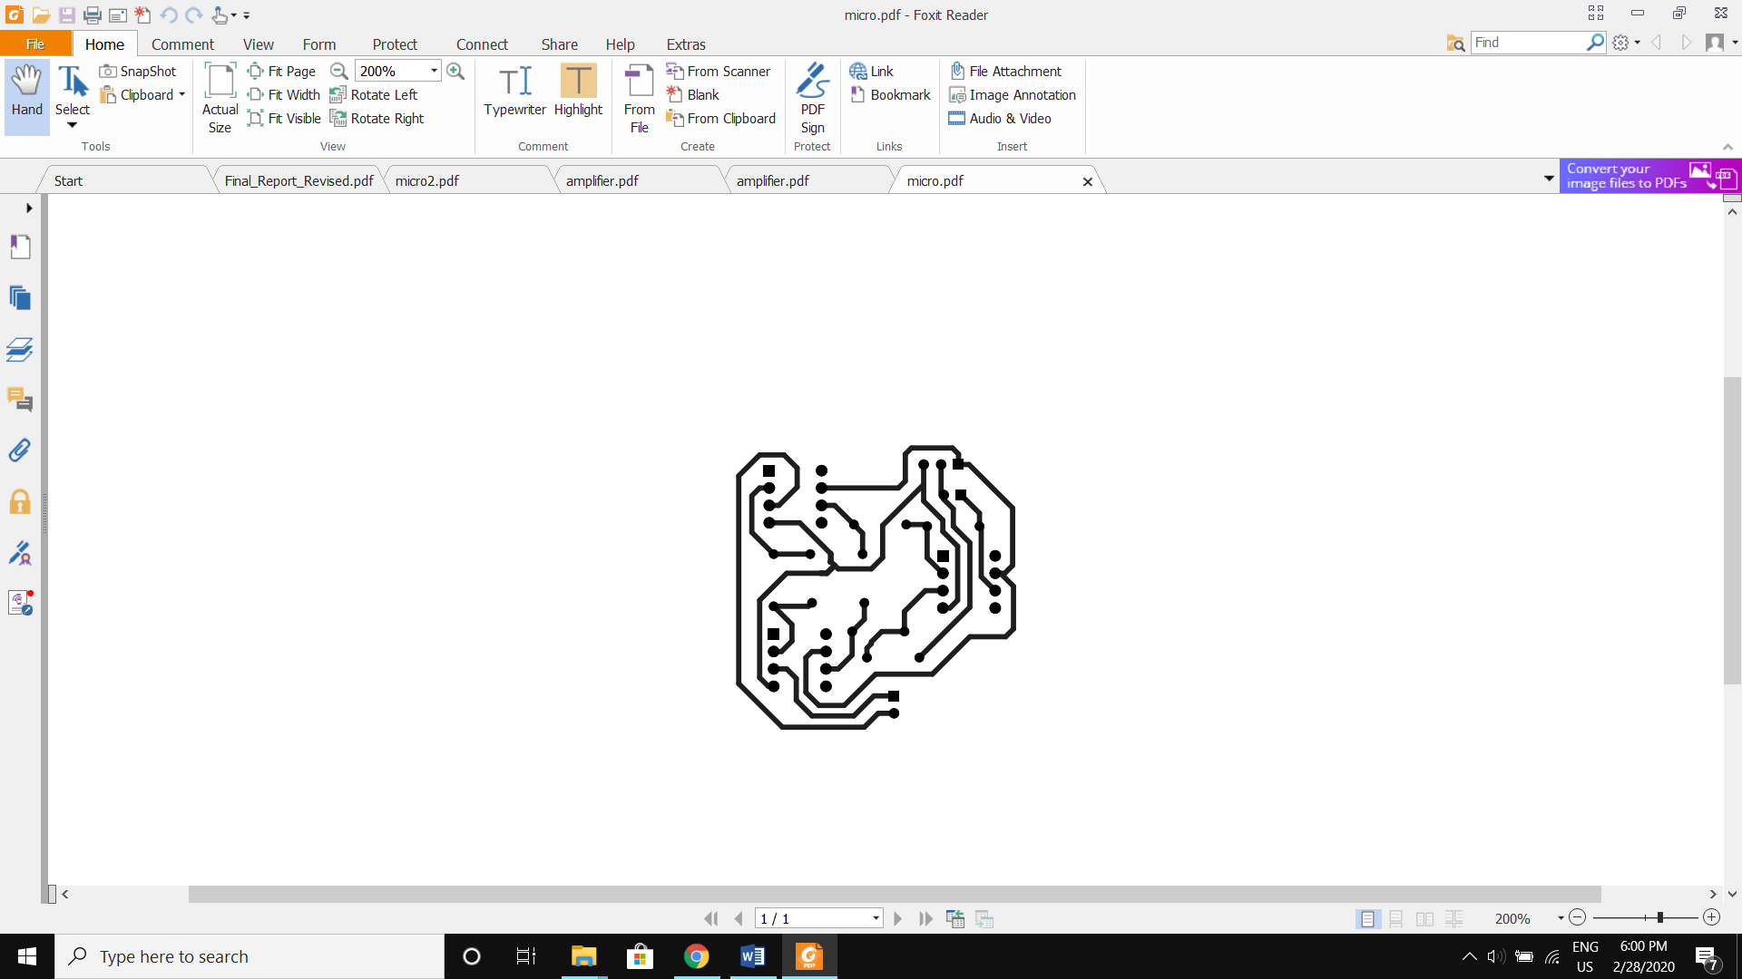

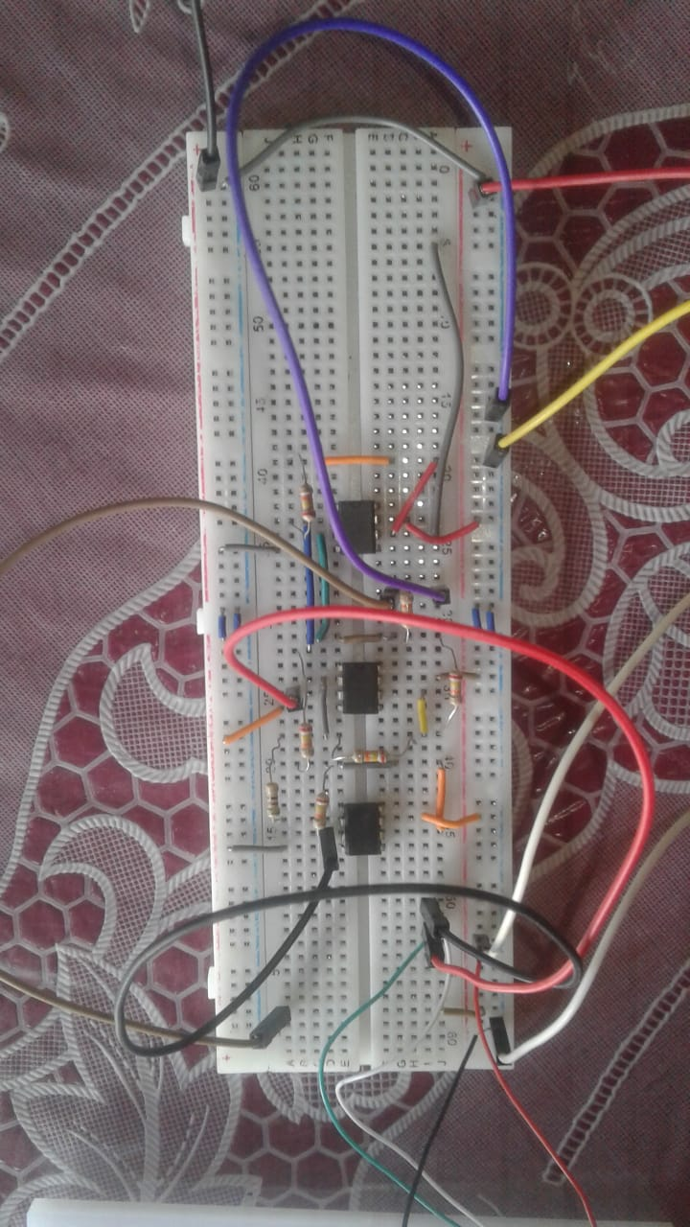

* + 1. **PCB of the amplifier circuit**

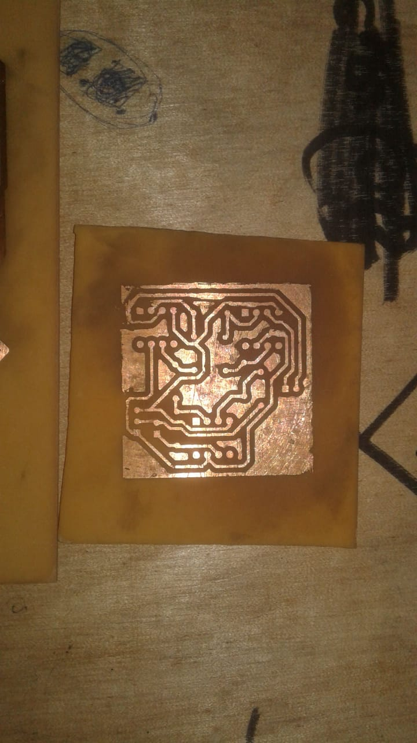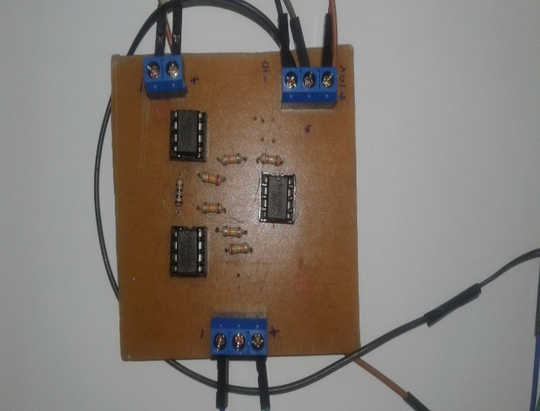

* 1. **Microcontroller Circuit**

In microcontroller circuit we used Atmega 328p microcontroller.

* + 1. **Pin-out**

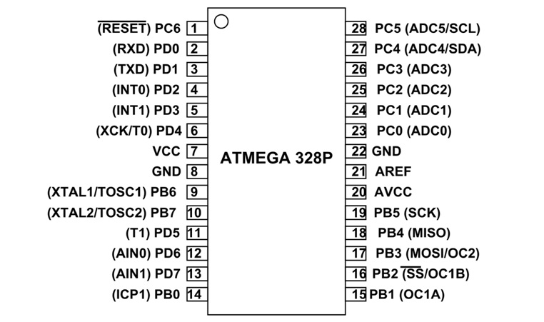

* + 1. **Components Used**
* Microcontroller (ATMEGA 328P)
* 5k ohm potentiometer
* 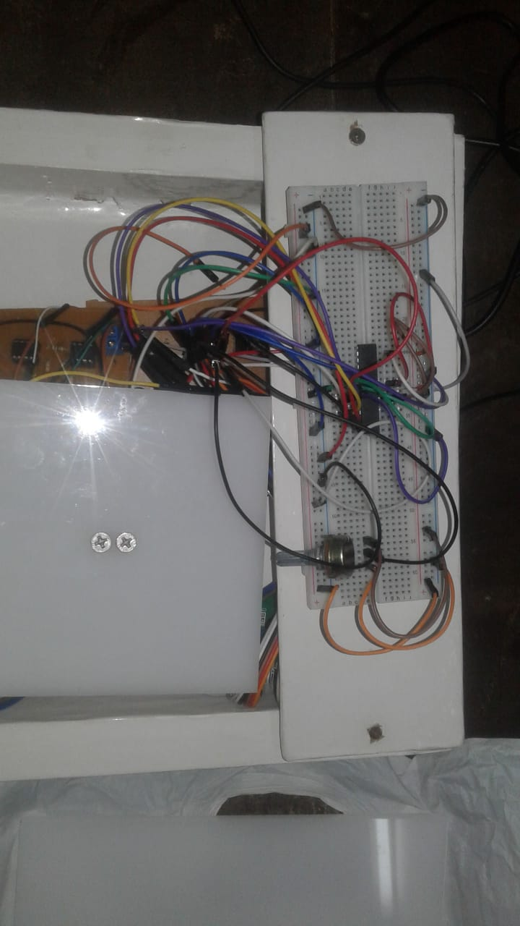3- 1nF capacitors
* Headers

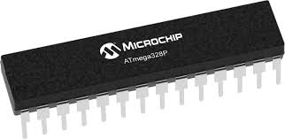

Potentiometer

ATMEGA 328p

* + 1. 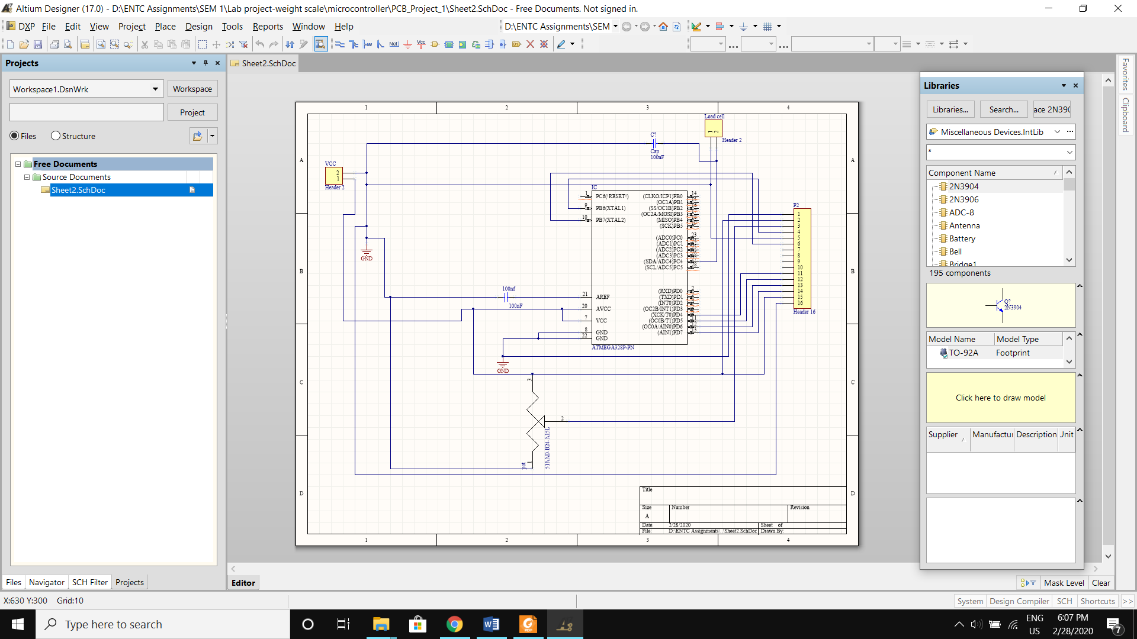**Schematic of the microcontroller circuit**
    2. **Layout of the microcontroller circuit**

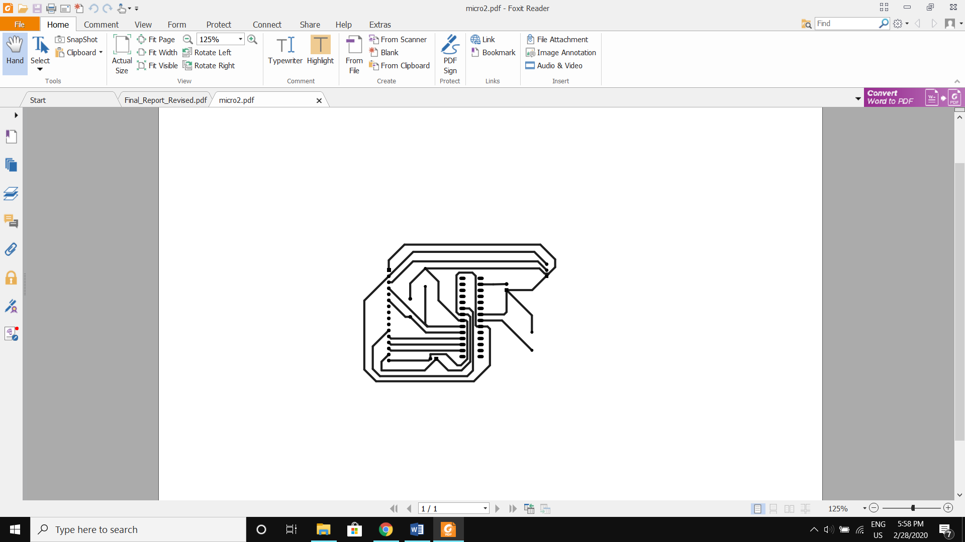

* + 1. **Code**

#define F_CPU 1000000UL

#define D4 eS_PORTD4

#define D5 eS_PORTD5

#define D6 eS_PORTD6

#define D7 eS_PORTD7

#define RS eS_PORTB6

#define EN eS_PORTB7

#include <stdlib.h>

#include <avr/io.h>

#include <util/delay.h>

#include "lcd.h"

void Adcinit()

{

DDRC= 0b00000000; // make port c as input

ADMUX=0b01000100; // using Avcc with external capacitor at vref and 10bit

//ADMUX=0b01100000;

ADCSRA = (1<<ADEN);

}

float AdcRead(int a)

{

unsigned short x;

//ADMUX=0b01100000 + a;

ADMUX=0b01000000 + a;

ADCSRA = ADCSRA|(1<<ADSC);

while (ADCSRA & (1<<ADSC));

//x=ADCH;

x = ADC;

return x ;

}

float y_axis,b;

int i;

char *n = "weight(g)";

int main(void)

{

DDRB=0xFF;

DDRD=0xFF;

Adcinit();

Lcd4_Init();

while (1)

{

b = 0;

for (i = 1; i < 1000; ++i)

{

y_axis=AdcRead(4);

y_axis=(y_axis*11 -2939);

_delay_ms(1);

b = b + y_axis ;

}

b = ((b/999)-116);

char *y="00000";

itoa(b,y,10);

Lcd4_Clear();

Lcd4_Set_Cursor(1,0);

Lcd4_Write_String(n);

Lcd4_Set_Cursor(2,0);

Lcd4_Write_String(y);

_delay_ms(1000);

}

}

1. **RESULTS AND DISCUSSION**
   1. **Results and Performance.**

After calibration, we observed the scale output for several known values of weights.

|  |  |
| --- | --- |
| **Actual Weight (g)** | **Scale Output (g)** |
| 100 | 15 |
| 200 | 120 |
| 250 | 174 |
| 300 | 224 |
| 350 | 277 |
| 500 | 436 |
| 750 | 596 |
| 1000 | 967 |
| 1200 | 1176 |
| 1300 | 1277 |
| 1500 | 1497 |
| 1600 | 1577 |
| 1800 | 1719 |
| 2000 | 2047 |
| 2500 | 2578 |
| 3000 | 3044 |
| 3500 | 3469 |
| 4000 | 3947 |
| 4500 | 4452 |
| 5000 | 4809 |

Then we calculated the error percentage for each weight and observed the variation of them.

|  |  |
| --- | --- |
| **Weight(g)** | **Error Percentage (%)** |
| 0 | 0 |
| 100 | 85 |
| 200 | 40 |
| 250 | 30.4 |
| 300 | 25.33 |
| 350 | 20.85 |
| 500 | 12.8 |
| 750 | 20.53 |
| 1000 | 3.3 |
| 1200 | 2 |
| 1300 | 1.77 |
| 1500 | 0.2 |
| 1600 | 1.43 |
| 1800 | 4.5 |
| 2000 | 2.35 |
| 2500 | 3.12 |
| 3000 | 1.46 |
| 3500 | 0.89 |
| 4000 | 1.32 |
| 4500 | 1.06 |
| 5000 | 3.82 |

* 1. **Final Outcome**

By using this weight scale we can measure up to 5kg with 50g accuracy for weights between 1kg and 4.5 kg. There appears to be a platform stabilization problem that affects small values of weights. This can be remedied by attaching more screws to the platform. The error greatly improves after about 1kg.

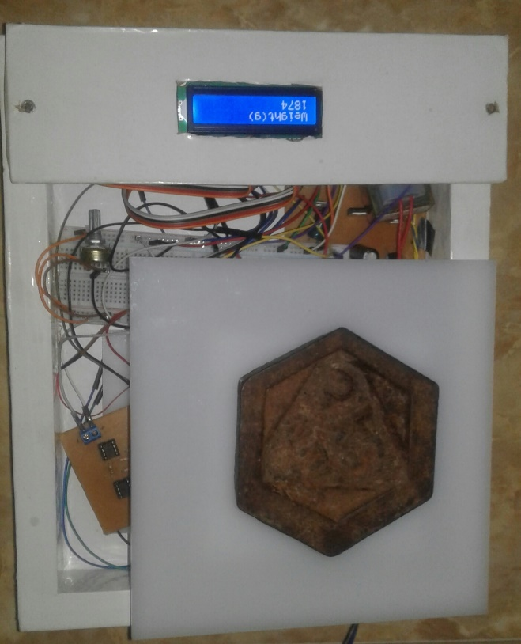

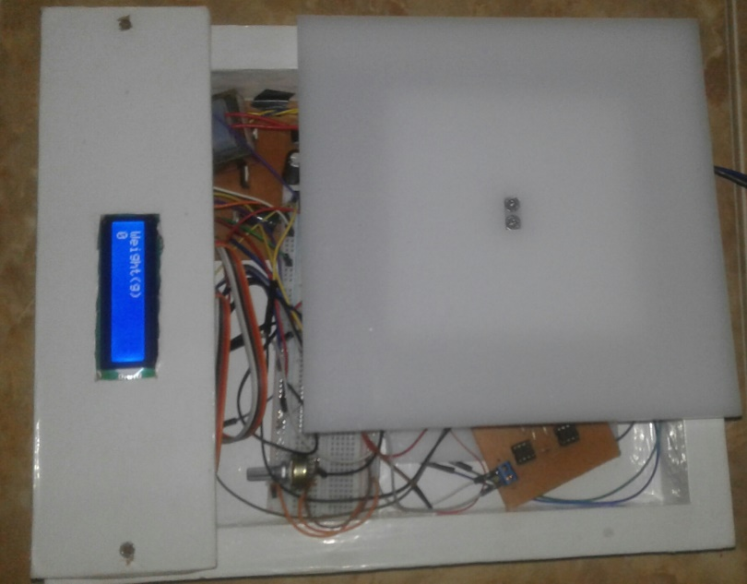

* 1. **Discussion**
     1. **Difficulties we faced, reasons for them and how we managed**

|  |  |  |
| --- | --- | --- |
| **Difficulties** | **Reasons** | **Solutions** |
| * Making the load cell output zero was a main challenge we faced. When no weight was applied, a negative voltage of 3.5mV was observed at the load cell | * To obtain values between 0 and 5V at the amplifier when 0 and 5kg are placed | * Construct a platform that had the required weight to make the load cell output zero. This approach was selected due to its simplicity |
| * When we use load cell we had to put heavy plate on load cell. Then it exceeds the maximum weight limit of 5kg load cell | * To protect the load cell | * So, we selected 10kg load cell |
| * First we decided to make the amplifier using LM324 IC. But we were unable to get higher gain and constant gain using it | * LM324 did not give a reliable output for high gain | * So, we decided to use OP07 op-amp |
| * Issues in manufacturing and soldering PCBs | * Paths were somewhat thin in size | * Used a thin diameter solder wire and 40W solder iron |
| * After assembling PCBs, output was not displayed | * Soldering problems, disconnections of paths, loose connection of wires | * Checked it again and soldered the needed place again * Fixed the wires tightly |
| * It was observed that there was a considerable amount of noise in the output from the amplifier | * Reduce the effect of noise | * A simple R-C filter was implemented * Code was modified to display an average of 500 readings |

1. **REFERENCE**

* What is load cell and how does it work? - <https://www.youtube.com/watch?v=bI1Vv4b6mPo>
* Digital scale calibration -<https://www.youtube.com/watch?v=DeEOUoL3uVk>
* How to calibrate your weight scale- <https://www.doityourself.com/stry/how-to-calibrate-your-digital-weight-scale>
* Atmega 328P - <http://ww1.microchip.com/downloads/en/DeviceDoc/Atmel-7810-Automotive-Microcontrollers-ATmega328P_Datasheet.pdf>

**END!**